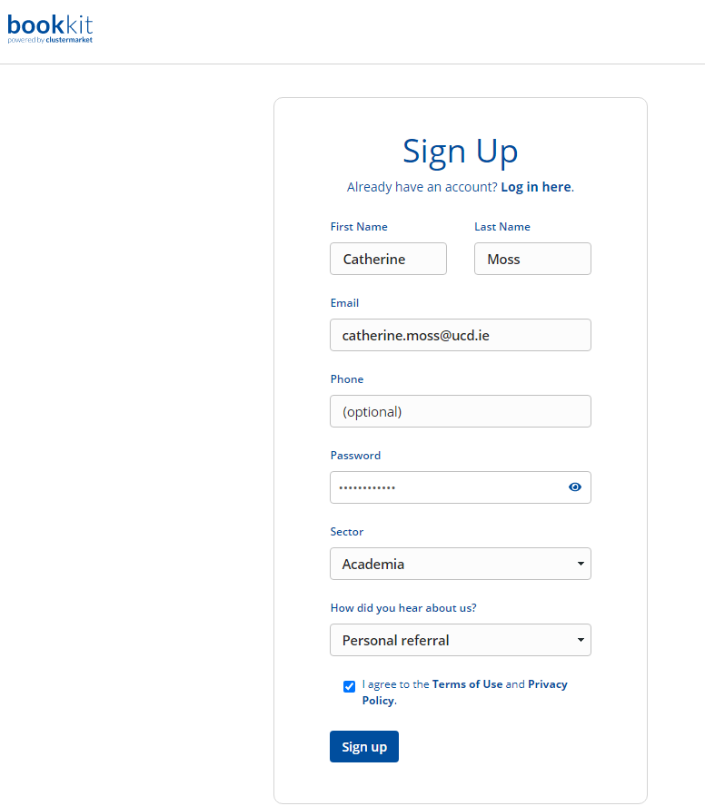
UCD Genomics-Conway Real-Time PCR:

- Once you receive your invite email, follow the link provided.
- Sign up to a new account if you don’t have one already as outlined below. (No need to supply a phone number as this can be viewed by other users.)
- The Quantstudio 7Flex qPCR System will be made available for booking in Lab Dashboard as soon as you are set up.

